Astana IT University
School of Software Engineering
Approved by
the Director of the School
_____________________Praveen K.
(signature, full name)
Discussed at the Department meeting
Protocol № _____
«____» ____________ 20____
Master's student research work №2
of the 2025-2026 academic year
Master student ____________________ Alimzhan Koshikov________________________
(full name)
Major ________________7M06105 - Computer Science and Engineering______________
(code, name)
The study duration of a Master programme: from 2025 till 2027
The topic of a master dissertation:
Исследование и реализация моделей виртуального наставника по программированию с персонализированной обратной связью студентам первого курса в реальном времени
Бірінші курс студенттеріне бағдарламалау бойынша дербестендірілген кері байланысты нақты уақыт режимінде қамтамасыз ететін виртуалды тәлімгер үлгілерін зерттеу және жүзеге асыру
Research and implementation of Virtual Mentor models in programming with real-time personalized feedback for first-year students
The dissertation topic is approved by the Academic Council of Astana IT University at the meeting, protocol №3-П «30» October, 2025
Master's thesis defense deadline: 2027
Master's student _________________________________ Koshikov A. A.
signature
Supervisor _________________________________ Tutkyshbayeva Sh. S.
signature
Astana, 2026

1. Actual implementation of the Individual Plan for Master's student
№ | Type of work | Planned completion dates | Actual completion dates | Reasons for non-compliance
1 | Preparation of the literature review and theoretical basis of the dissertation: CS1 learning difficulties, virtual mentors, LLM-based feedback, and automated code analysis. | January-March 2026 | February-March 2026 | None (completed for the current stage)
2 | Development of the SocratesAI research concept and architecture: code analysis, feedback-state prediction, personalized hint generation, and interaction logging. | March-April 2026 | March-April 2026 | None (completed on schedule)
3 | Preparation and peer review of the SIST 2026 manuscript “Real-Time Virtual Mentor for Introductory Programming Feedback”. | January-March 2026 | Submitted and reviewed in March 2026; the paper was not accepted | Reviewers noted that the manuscript was more pedagogical and required stronger technical depth, dataset description, benchmark comparison, and validation.
4 | Technical redirection of the research and preparation of the new IEEE manuscript “A Machine Learning Model for Real-Time Personalized Feedback in Introductory Programming”. | April-June 2026 | May-June 2026; submitted to the 2026 IEEE 3rd International Student Conference on Digital Generation | None; the work was completed as a response to the SIST review comments.
5 | Implementation of the SocratesAI MVP and initial ML decision layer: Spring Boot backend, Python ML service, feedback-state prediction, and interaction_logs storage. | May-September 2026 | MVP and initial experiments completed in May-June 2026; further classroom validation remains planned | Work is within schedule, full CS1 testing remains planned for 2026–2027

2. Participation of a master's student in conferences, scientific seminars, round tables:
a) in AITU: regular discussion of the SocratesAI research direction and dissertation materials with the scientific supervisor, including analysis of the SIST 2026 review comments and adjustment of the work toward the machine-learning decision layer of the virtual mentor.
b) 2026 IEEE 6th International Conference on Smart Information Systems and Technologies (SIST 2026): the manuscript “Real-Time Virtual Mentor for Introductory Programming Feedback” was submitted as Paper ID 314 and reviewed in March 2026. The paper was not accepted; the reviewers recommended strengthening the technical contribution, dataset description, benchmark comparison, and validation.
c) 2026 IEEE 3rd International Student Conference on Digital Generation: the revised technical manuscript “A Machine Learning Model for Real-Time Personalized Feedback in Introductory Programming” was prepared and submitted in June 2026. The manuscript presents the feedback-state model, empirical evaluation, and SocratesAI integration.
3. Publications of the master's student on the research topic (type of publication, title of publication, place of publication, volume in printed sheets)
№ | Title of the article | Publication or place | Number of printed sheets
1 | A Machine Learning Model for Real-Time Personalized Feedback in Introductory Programming | Submitted to the 2026 IEEE 3rd International Student Conference on Digital Generation, June 2026 | 5

Master's student _________________________________ Koshikov A. A.
signature
Supervisor _________________________________ Tutkyshbayeva Sh. S.
signature

Appendix 1
Detailed description of the work completed during the current reporting period according to the Individual Plan
Reporting period: February-June 2026.
During the reporting period, the work moved from the literature-review and architecture-planning stage to implementation and empirical evaluation of the SocratesAI virtual mentor. The main verified outputs are: analysis of the SIST 2026 review comments, preparation of a more technical IEEE manuscript, development of the SocratesAI MVP, and initial machine-learning experiments for feedback-state prediction.
The dissertation materials are treated as work in progress. The completed MVP and the submitted manuscript provide technical evidence for the dissertation, while full classroom testing with first-year students remains planned for the next academic period according to the Individual Plan.
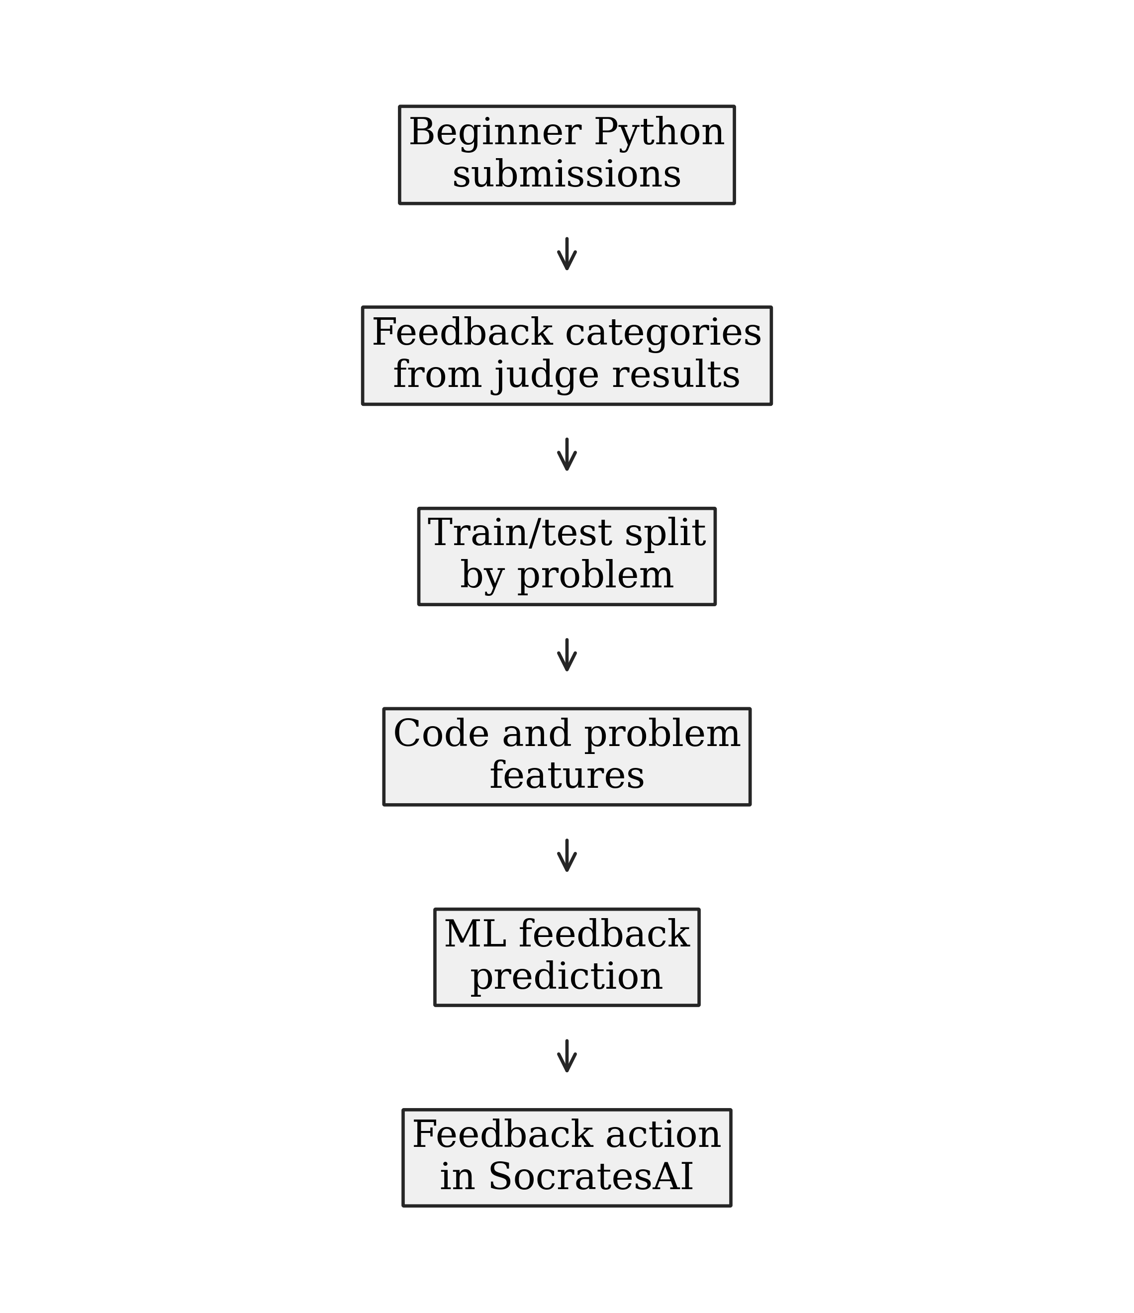
Figure A1. Machine-learning pipeline from beginner programming submissions to a feedback-state model used by SocratesAI.

1. Research redirection after the SIST 2026 review
The first manuscript for the period was “Real-Time Virtual Mentor for Introductory Programming Feedback”, submitted to IEEE SIST 2026 as Paper ID 314. The reviews acknowledged the relevance of the topic, but indicated that the contribution was too close to pedagogical system integration and needed stronger technical depth, clearer dataset evidence, benchmark comparison, and validation.
Based on this feedback, the research direction was narrowed from a general virtual-mentor architecture to a technical decision layer: predicting the appropriate feedback state before generating a hint. This correction is consistent with the dissertation topic because the virtual mentor still provides personalized real-time feedback, but the scientific focus is now supported by a supervised machine-learning experiment.
2. New technical manuscript and ML methodology
The new manuscript, “A Machine Learning Model for Real-Time Personalized Feedback in Introductory Programming”, was prepared and submitted to the 2026 IEEE 3rd International Student Conference on Digital Generation. It formulates mentoring as feedback-state prediction with five states: accepted, semantic debugging, execution safety, efficiency review, and syntax repair.

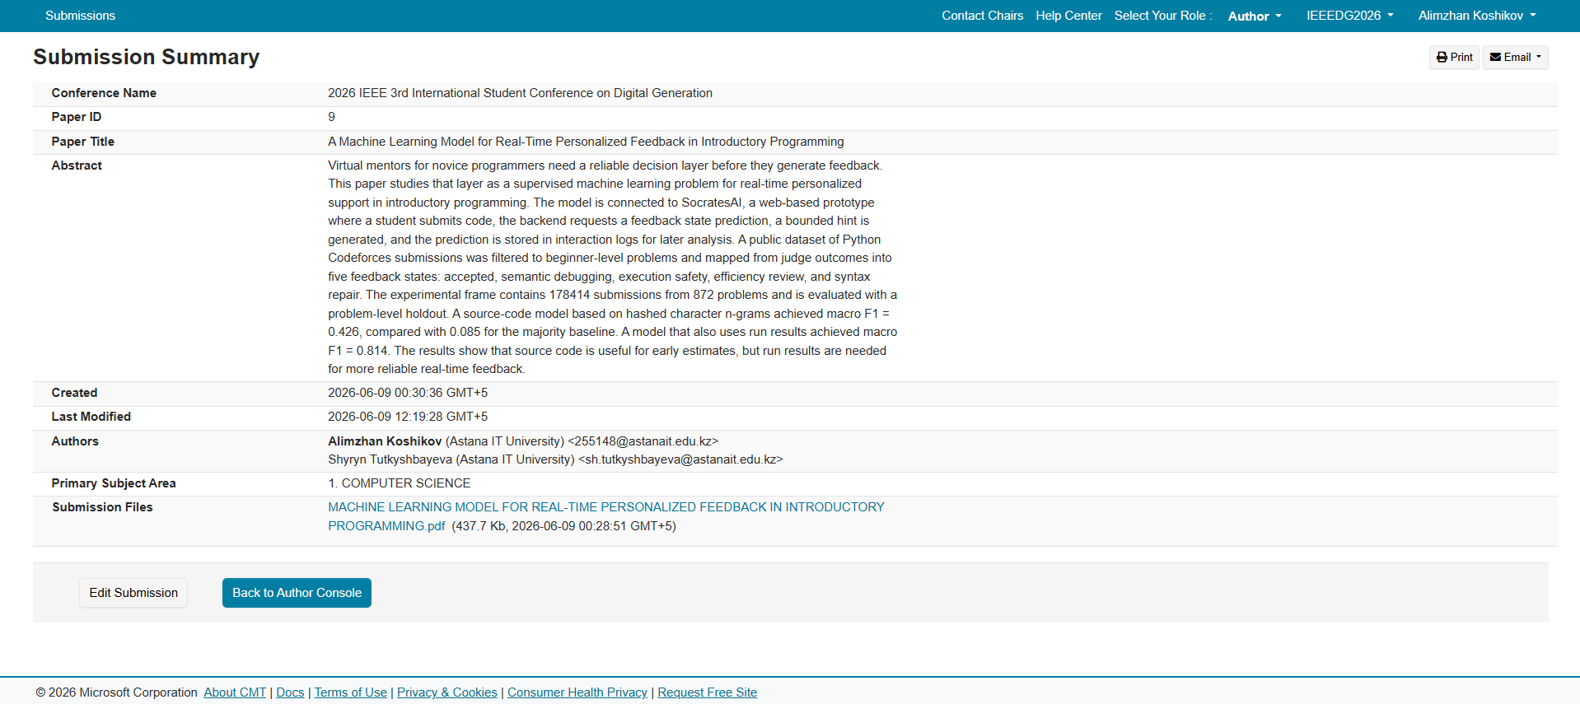
Figure A2. Submission to the 2026 IEEE 3rd International Student Conference on Digital Generation

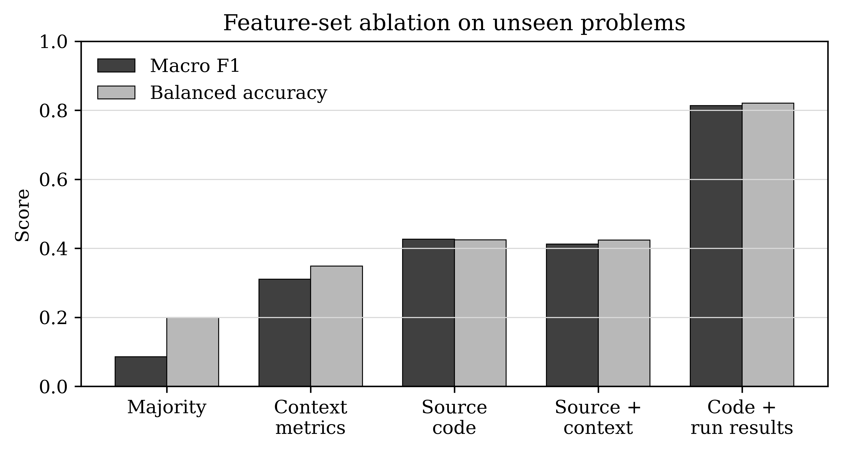
Figure A3. Feature-set comparison for the feedback-state prediction models.
The empirical frame uses 178,414 Python submissions from 872 beginner-level Codeforces problems, evaluated with a problem-level holdout. The source-code model reached macro F1 = 0.426 compared with 0.085 for the majority baseline, while the code-and-run model reached macro F1 = 0.814. These results show that source code contains useful early signals, but execution results are important for reliable feedback-state prediction.
3. SocratesAI MVP implementation
The SocratesAI MVP was implemented as the practical component of the master's thesis project. The prototype connects a Spring Boot backend with a Python ML service. The backend sends code, task context, and run-result signals to the prediction endpoint, receives a feedback state and confidence score, uses this state to guide bounded hint generation, and stores the prediction in interaction_logs for later analysis.
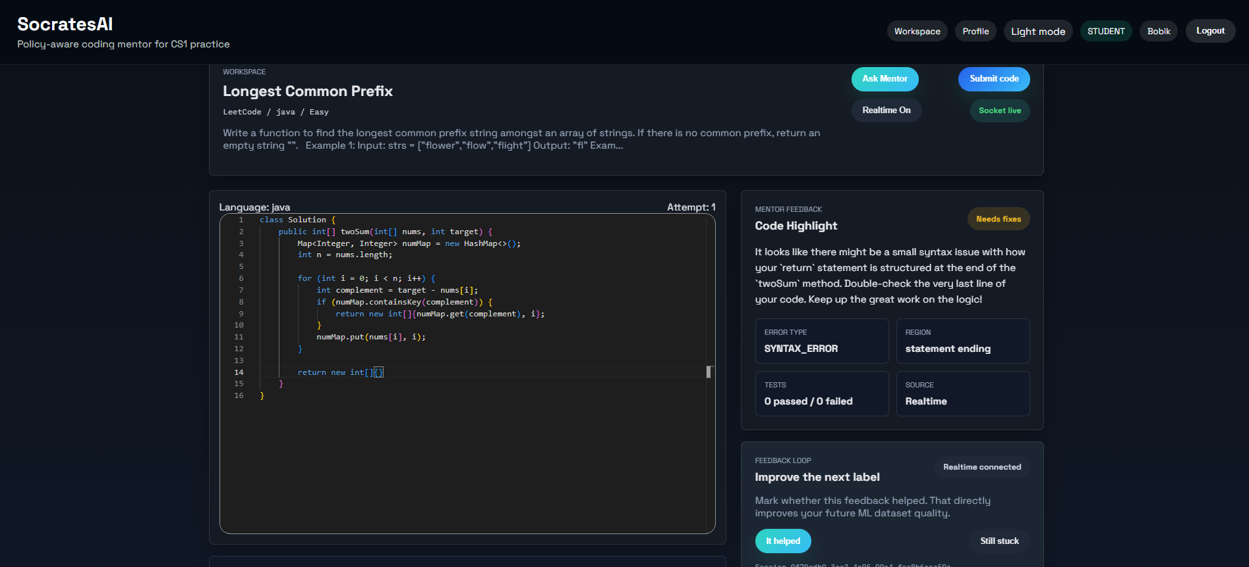
Figure A4. SocratesAI interface with model-guided feedback next to the student's code.
The MVP supports the planned dissertation structure because it connects the research model with an implemented application. At the current stage, Codeforces data is used as an initial external training and evaluation source; SocratesAI logs are intended to become the target-domain evidence for future classroom evaluation.
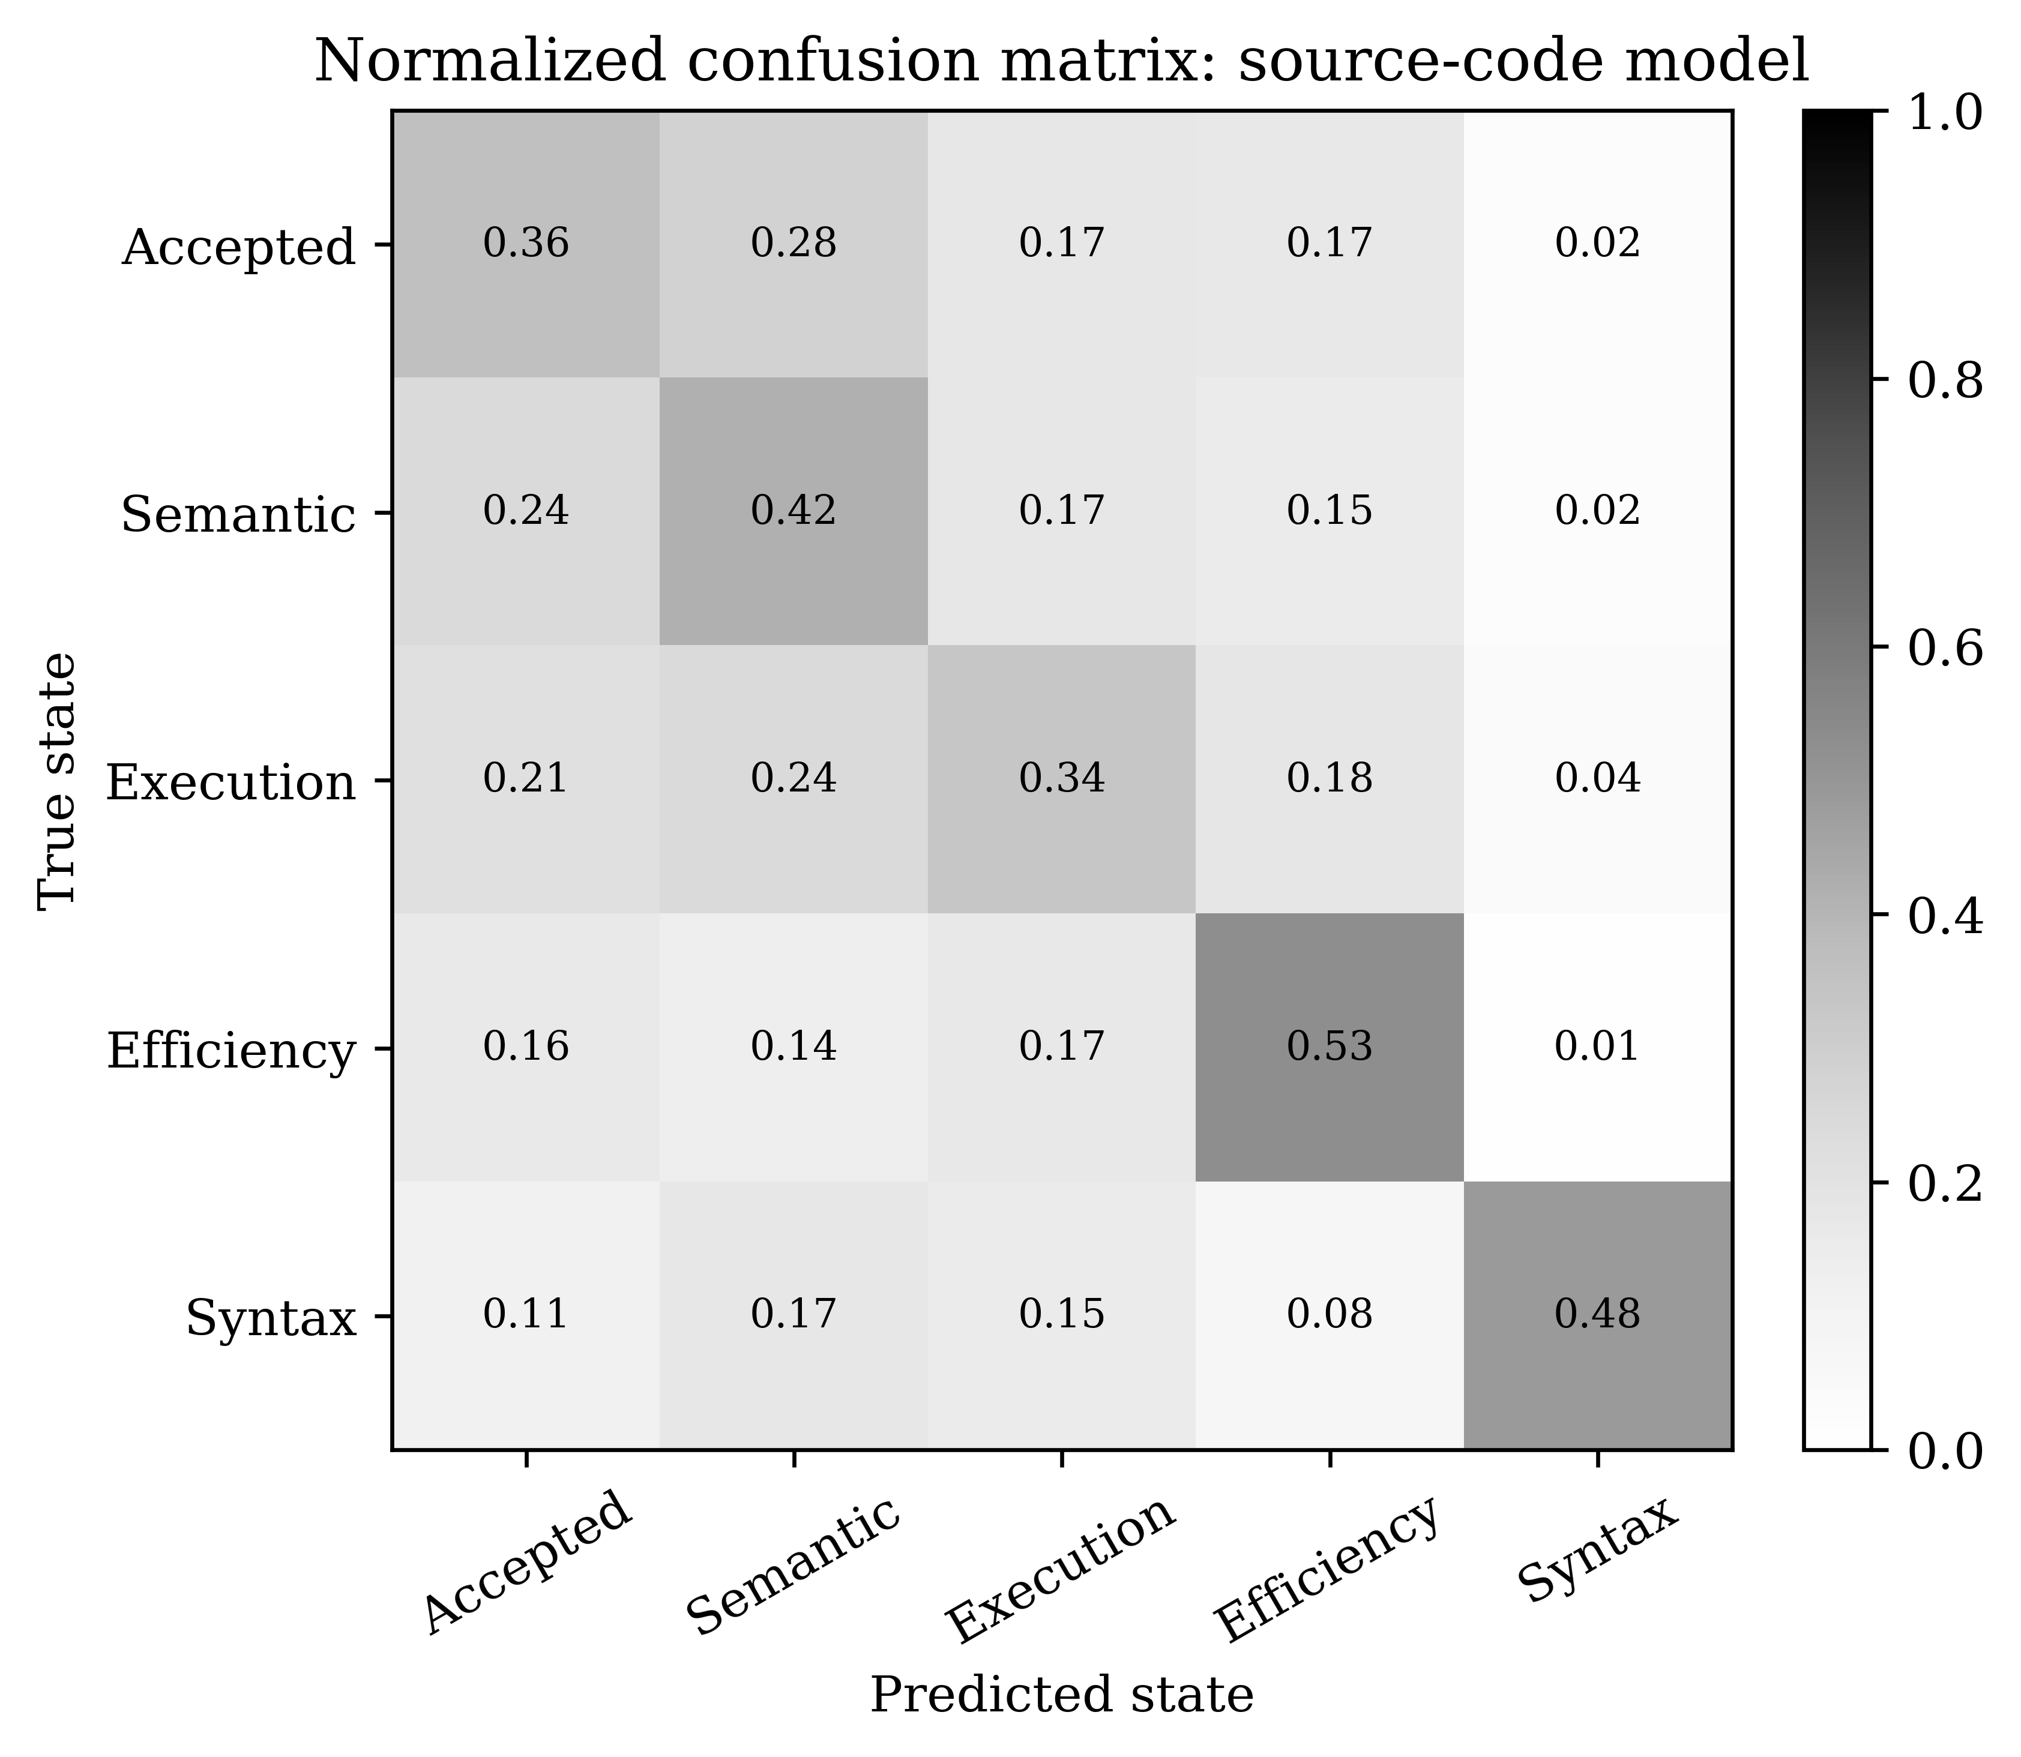
Figure A5. Source-code model confusion matrix showing which feedback states remain difficult to distinguish.
4. Results recorded for the reporting period
The reporting period produced a reviewed SIST manuscript, a corrected technical research direction, a submitted new IEEE manuscript, the SocratesAI MVP, and initial ML evaluation results for the mentor decision layer. The next stage is to collect more target-domain interaction logs, prepare classroom or historical-data validation for CS1 tasks, improve the feedback-state taxonomy, and continue writing the implementation and results chapters of the dissertation.

